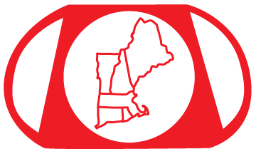
New England Paperweight Collectors Association

NEPCA REGISTRATION FORM

MEETING DATE: September 17, 2022
LOCATION: Haight-Brown Vineyard
29 Chestnut Hill Rd, Litchfield CT 06759

Name: _______________________________________________________________________________
Name: _______________________________________________________________________________
Address: _____________________________________________________________________________
City: _______________________________________ State:_________ Zip code: __________________
Telephone No: (_______) ________ - ______________
Email Address: _______________________________________________________________________

We will try our best to accommodate your dietary restrictions.
I need a Gluten Free lunch (quantity) _________ I need a Vegetarian Lunch (quantity) _________

Saturday September 17:
Fall Meeting and Luncheon – 9:00am to 3:30pm
# of members attending _______ x $35 ea
# of guests attending _______ x $40 ea _________
# of artist or dealer tables _______ x $50 ea

TOTAL ENCLOSED $ ____________________

Your check made payable to NEPCA must be received no later than
Friday, Sept 9, 2022
NOTE: Member paperweight sales at this meeting – maximum of FIVE (5) paperweights or related items per household membership. No charge and no need to reserve a space in advance.
PLEASE NOTE - Mail your check and completed registration form to:
New England Paperweight Collectors Association
PO Box 1334
Framingham, MA 01701

For more information, please contact: nepca.pres@gmail.com

