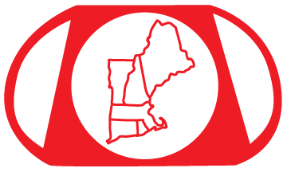
New England Paperweight Collectors Association

2023 Membership Application & Renewal Form
Please print this page, fill out the information and mail it with your payment to the address below.

Name #1:
Name #2:
Street Address:
City: State: Zip:
Telephone: Telephone 2:
Email Address #1:
Email Address #2:
If this is a renewal, please circle any changes to your contact information.
NOTE: NEPCA will use your personal information (name, address, email address) to keep you informed about New England Paperweight Collectors Association events and other paperweight related events, such as exhibits, auctions and talks. NEPCA will never give your contact information to a third party.
Individual Membership: $25 per year $
Family Membership (2 people): $40 per year $
Total enclosed: $
New members: How did you learn about NEPCA?

Please make checks payable to: New England Paperweight Collectors Association
Your check is your receipt.

Mail to:
New England Paperweight Collectors Association
P.O. Box 1334
Framingham, MA 01702

For more information, please contact: nepca.pres@gmail.com

